**Reading data from CSV and JSON files into a data frame:**

1. **Reading CSV:**

import pandas as pd

data = pd.read_csv('Iris.csv')

print(data)

**Output:**

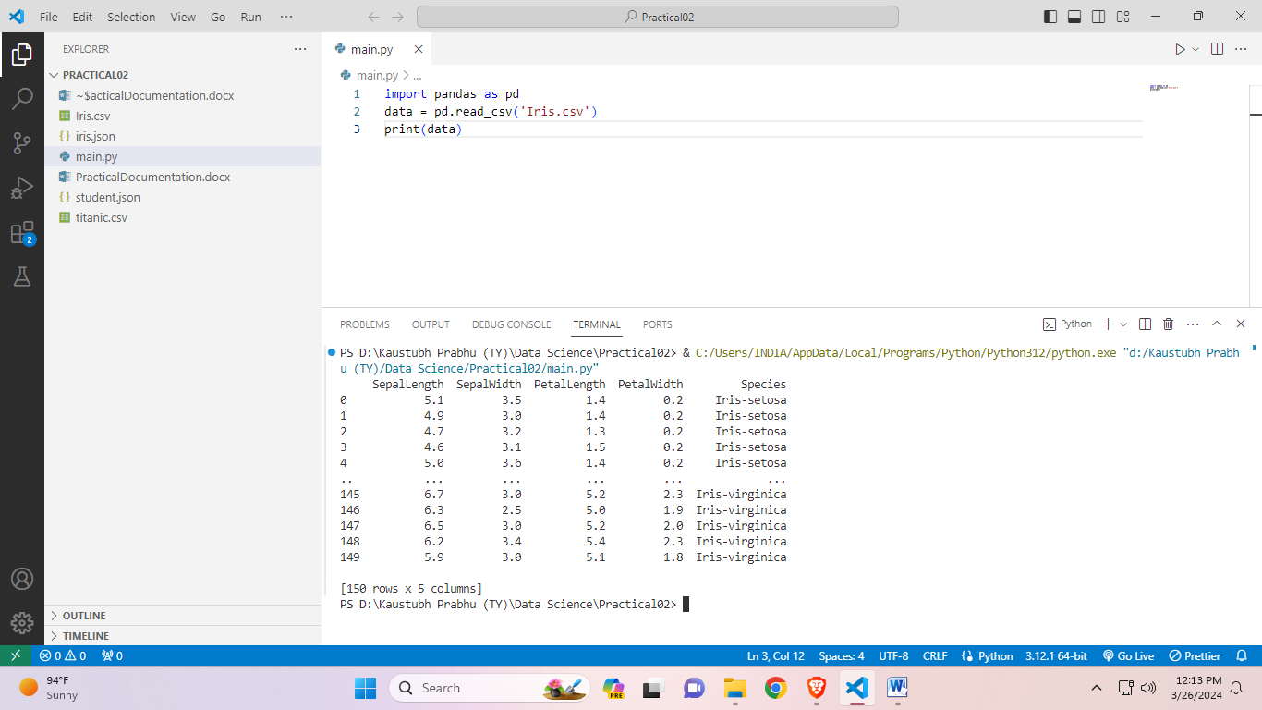

1. **Reading JSON:**

import pandas as pd

data = pd.read_json('iris.json')

print(data)

**Output:**

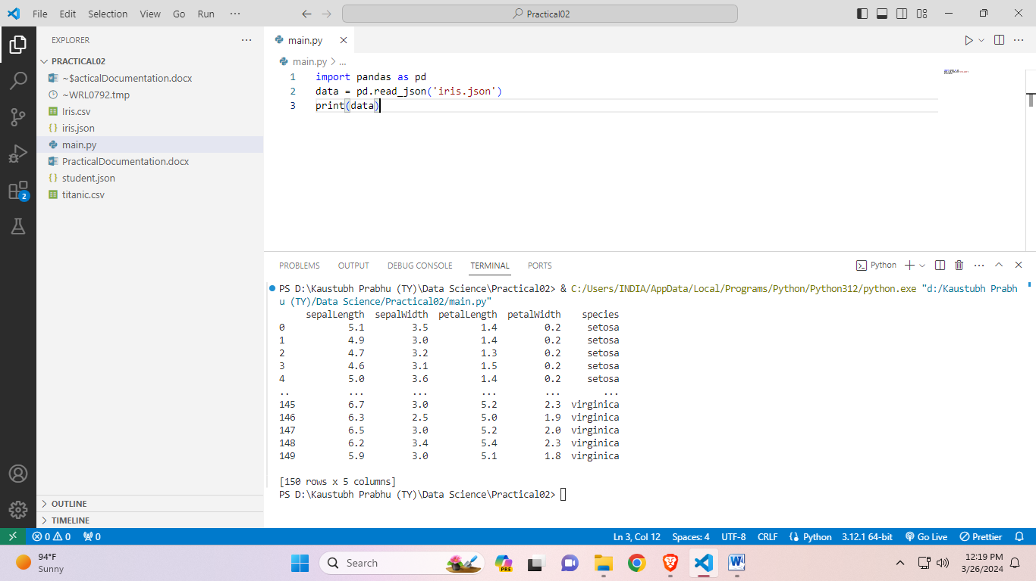

**Handling missing values and outliers:**

1. **Using fillna():**

import pandas as pd

data = pd.read_csv('titanic.csv')

print(data)

updatedData = data.fillna(value=0)

print(updatedData)

**Output:**

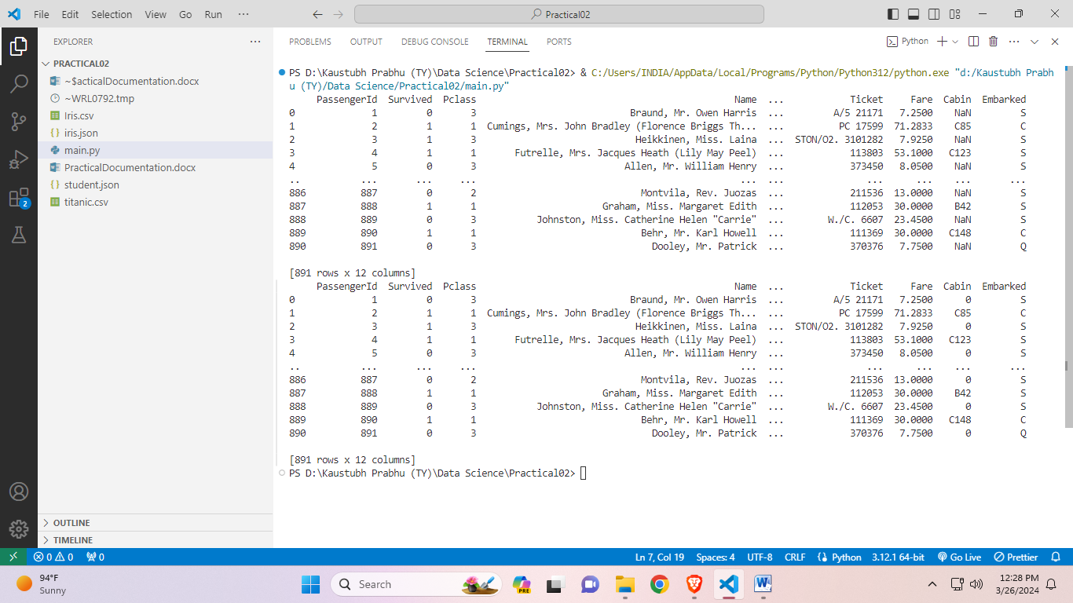



1. **Using dropna():**

import pandas as pd

csvFile = pd.read_csv("./DS/titanic.csv")

print(csvFile)

updatedcsvFile = csvFile.dropna()

print(updatedcsvFile)

**Output:**

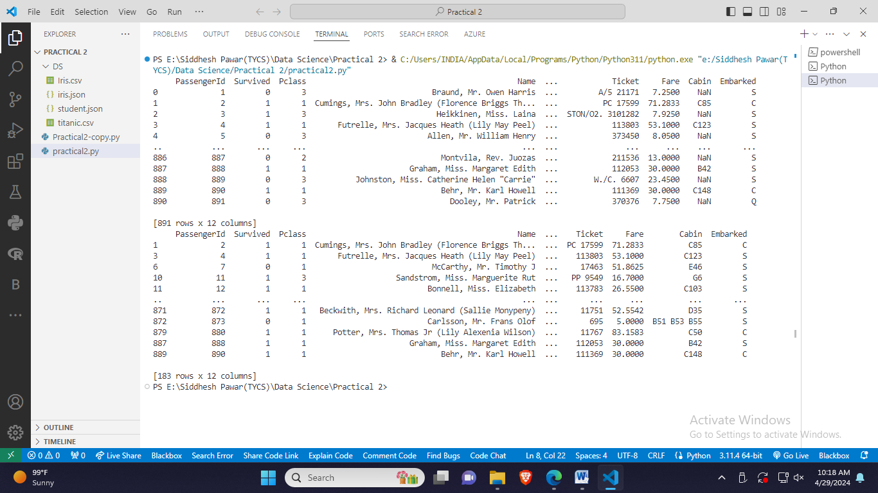



**Manipulate and transform data using functions:**

1. **Filtering:**

import pandas as pd

data = pd.read_csv('titanic.csv')

survived = data[data['Survived'] == 1] # Filtering data for survived

print(survived)

**Output:**



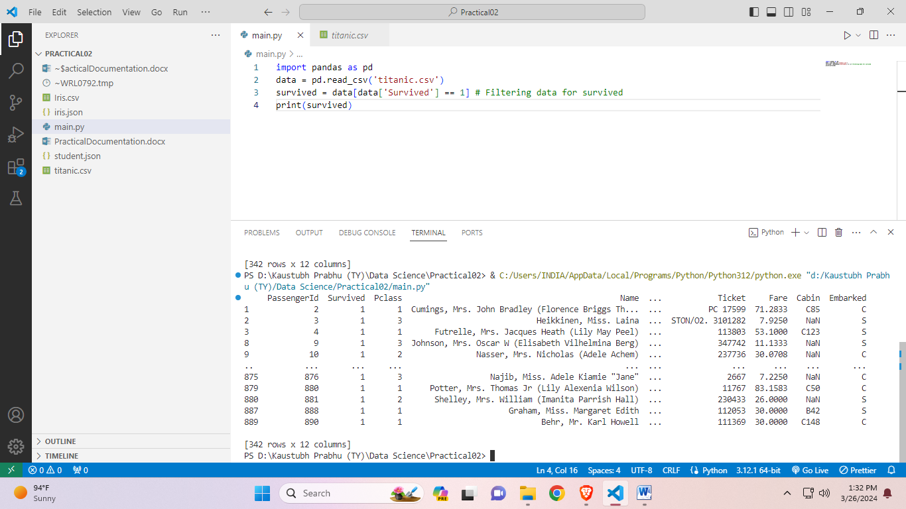

1. **Sorting:**

import pandas as pd

csvFile = pd.read_csv("./DS/titanic.csv")

print(csvFile)

ageSorted = csvFile.sort_values(by=['Age'])

print(ageSorted)



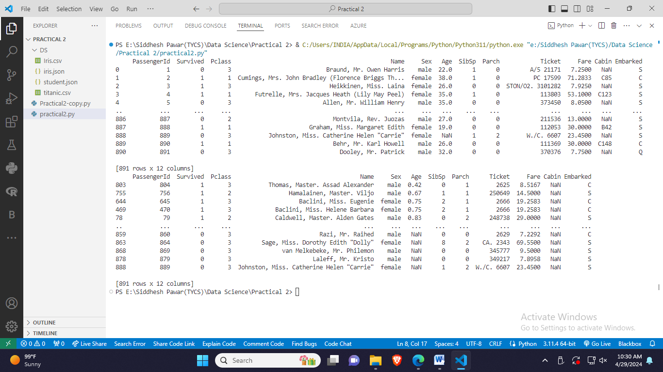

1. **Grouping:**

import pandas as pd

csvFile = pd.read_csv("./DS/titanic.csv")

print(csvFile)

groupedbyEmbarked = csvFile.groupby(["Survived"]).mean(["Pclass","Sex", "Age"])  #Grouping by survival status and calculating

print(groupedbyEmbarked)



